Laboratory Report: Pressure & Refrigeration

Submitted by: Peter Surname (Group Leader) K1234567

Andrew Surname K2345671

Lucas Surname K3456712

James Surname K4567123

Judas Surname K5671234

Key dates: Date of practical: DD/MM/YYYY

Deadline: DD/MM/YYYY

Date of submission: DD/MM/YYYY

**Contribution Table:**

|  |  |  |  |
| --- | --- | --- | --- |
| Student | Course | Contribution | Picture |
| Peter Surname | Aerospace Engineering | Abstract | See the source image |
| Andrew Surname | Aviation | Introduction | See the source image |
| Lucas Surname | Astro | Results | See the source image |
| James Surname | Mechanical Engineering | Discussion  References | See the source image |
| Judas Surname | Civil Engineering | No Contribution | See the source image |

**Table of Contents**

Abstract......................................................................................................................................3

Introduction ...............................................................................................................................4

Method and Experimental Procedures.......................................................................................5

Theory........................................................................................................................................4

Results........................................................................................................................................8

Discussion................................................................................................................................12

Conclusions..............................................................................................................................13

Recommendations....................................................................................................................13

References................................................................................................................................14

Appendix..................................................................................................................................14

**Abstract** (new page-only abstract here)

Edit, edit, edit, edit, 150/200 words max, 1.5 lines of spacing, single paragraph. In this page, only one paragraph, justified please. The abstract is normally written in one paragraph.

**Introduction** (new page-all sections from here)

Edit, edit, edit, edit, as many words and as many paragraphs as necessary, 1.5 lines of spacing. From this page, many sections/subsections can be together in the same page, justified please.

**Methods and Experimental Procedures**

Edit, edit, edit, edit, as many words and as many paragraphs as necessary, 1.5 lines of spacing. From this page, many sections/subsections can be together in the same page, justified please.

**Subsection if necessary (different font size here please)**

Edit, edit, edit, edit, as many words and as many paragraphs as necessary, 1.5 lines of spacing. From this page, many sections/subsections can be together in the same page, justified please.

**Theory**

Edit, edit, edit, edit, as many words and as many paragraphs as necessary, 1.5 lines of spacing. From this page, many sections/subsections can be together in the same page, justified please.

When using an equation, please do not copy and paste, absolutely not. Instead use a proper equation by inserting the formula (as follows). For instance, the circumference of the section (*L*) is determined as follows:

$L=πd$ Eq. 1,

where *d* is the diameter of the cross section and is measured in units of length.

Every time you use a formula you can refer to it as Eq.1. This is the professional manner of showing it. If you need to refer to the equation, you always use Eq.1.

**Subsection if necessary (different font size here please)**

Edit, edit, edit, edit, as many words and as many paragraphs as necessary, 1.5 lines of spacing. From this page, many sections/subsections can be together in the same page, justified please.

**Subsection if necessary (different font size here please)**

Edit, edit, edit, edit, as many words and as many paragraphs as necessary, 1.5 lines of spacing. From this page, many sections/subsections can be together in the same page, justified please.

**Subsection if necessary (different font size here please)**

Edit, edit, edit, edit, as many words and as many paragraphs as necessary, 1.5 lines of spacing. From this page, many sections/subsections can be together in the same page, justified please.

**Results**

Edit, edit, edit, edit, as many words and as many paragraphs as necessary, 1.5 lines of spacing. From this page, many sections/subsections can be together in the same page, justified please.

DO NOT USE the picture of the results. That was raw data. Do plot the data using e.g., excel. DO DETERMINE the values of YOUNG’S MODULUS. Most reports just have the picture inserted. That is not acceptable.

Use consistent units, consistent writing style, especially when there are many contributors. Do use units as it is unacceptable to say, for instance, the length is 3. It is just wrong. This is engineering. Do use units.

When using figures, the text above or below needs to refer to them. For instance, a figure, such as Figure 1, should never be used because it is just a printing from the apparatus. At level 4, you have to produce your own professional plots, graphs, and tables. Note that any text or labelling within the figure should be readable, otherwise there is no point on using the image.

Note, too, that absolutely all images, graphs, or tables need be captioned. This is a must as a report with unreadable or uncaptioned figures is unacceptable.

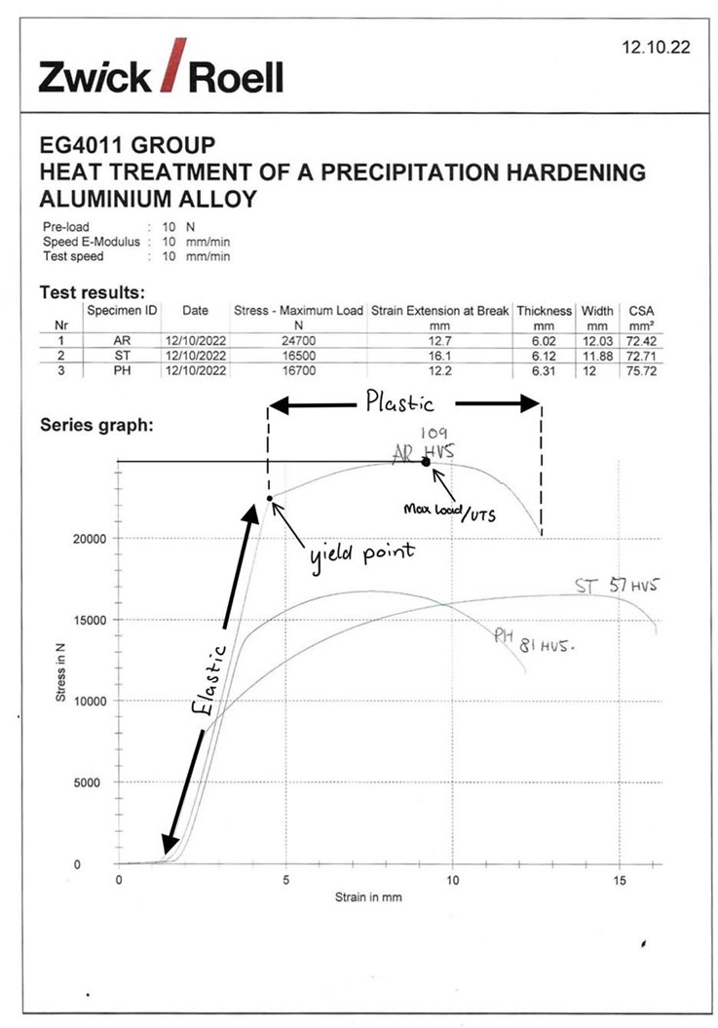

**Figure 1**. This image should never be used because it is just a print (smaller font here!).

DO NOT USE the picture of results printed at the lab, as the one in Figure 1. That was raw data. Do plot the data using a software, e.g., excel. DO DETERMINE the values of YOUNG’S MODULUS. Most reports just have the picture inserted. That is not acceptable.

**Discussion**

The discussion is based on the results you have obtained. Explain why you obtained those. Analyse the calculations you have done. What the implications are. Be professional, do not copy and paste form Wikipedia.

Edit, edit, edit, as many words and as many paragraphs as necessary, 1.5 lines of spacing. From this page, many sections/subsections can be together in the same page, justified please.

**Subsection if necessary (different font size here please)**

Edit, edit, edit, edit, as many words and as many paragraphs as necessary, 1.5 lines of spacing. From this page, many sections/subsections can be together in the same page, justified please.

**Conclusions**

This section is the part to be written after analysing results. How can someone conclude on something that has not been produced or analysed yet? Edit, edit, edit, edit, as many words and as many paragraphs as necessary, 1.5 lines of spacing. Typically, no more than two paragraphs here. Remember, a well-presented report should be very well-written, clear, concise writing, all grammar/spelling correct, well structured, not a patchwork.

**Recommendations**

Use this template, or create something similar, but be professional. Learn at level 4 how to produce an outstanding (or close to) report. This section is the last part to be written. How can someone conclude on something that has not been produced or analysed yet?

**References**: (new page here, references only)

[1] Author, H. (2017) Strain Hardening | Definition, Effects and Ductility, Strain Hardening Definition | Ductility & Effects of Strain Hardening. Available at: https://www.example.org/example.html (Accessed: October 14, 2022).

[2] Author, H. (2017) Strain Hardening | Definition, Effects and Ductility, Strain Hardening Definition | Ductility & Effects of Strain Hardening. Available at: https://www.example.org/example.html (Accessed: October 14, 2022).

[3] Author, H. (2017) Strain Hardening | Definition, Effects and Ductility, Strain Hardening Definition | Ductility & Effects of Strain Hardening. Available at: https://www.example.org/example.html (Accessed: October 14, 2022).

[4] Author, H. (2017) Strain Hardening | Definition, Effects and Ductility, Strain Hardening Definition | Ductility & Effects of Strain Hardening. Available at: https://www.example.org/example.html (Accessed: October 14, 2022).

**Appendix**: (if necessary, new page here)